Amazon Global Market Analysis

Dashboard Output:

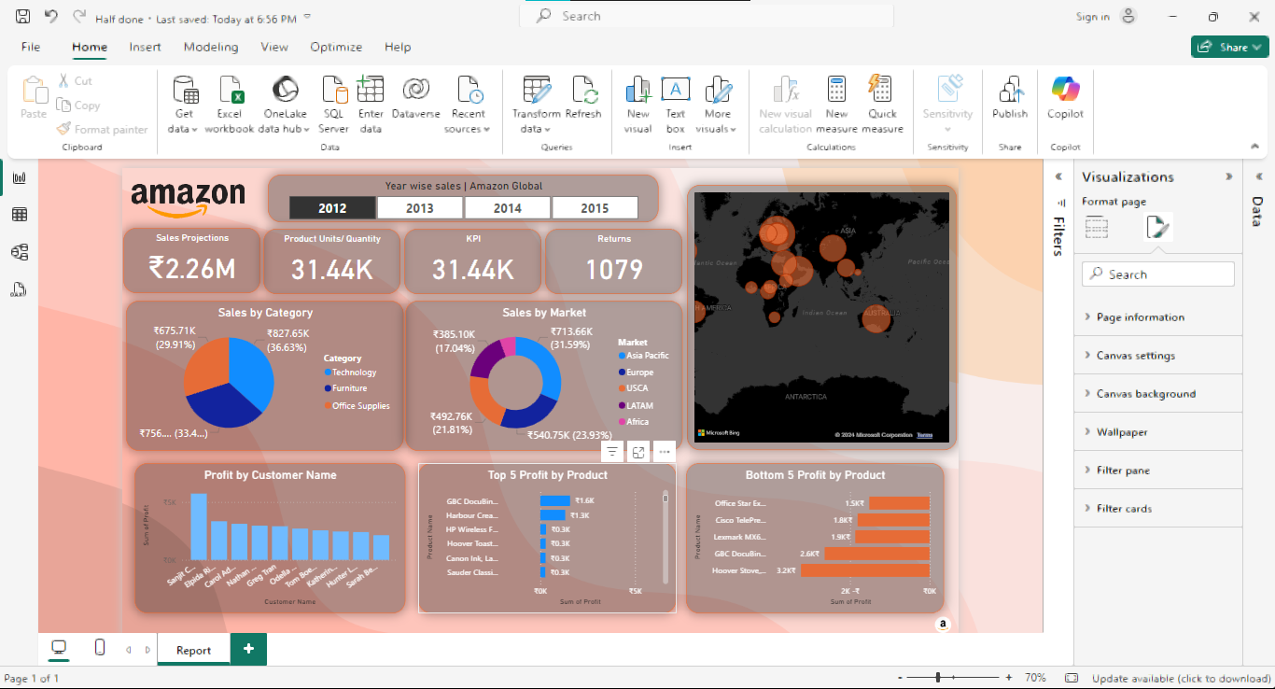

Problem 1: Analysis of the Top profitable product in 2015?

Output:

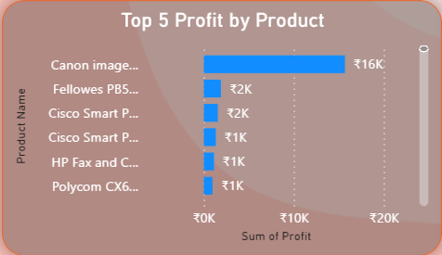

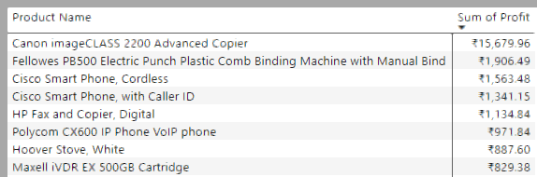

Problem 2: Analysis of the most sales in 2013?

Output:

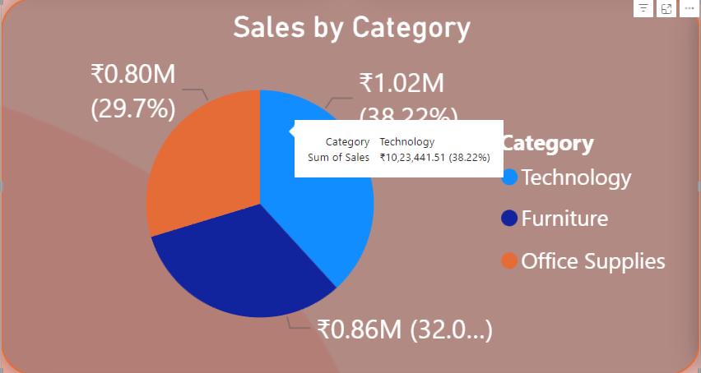

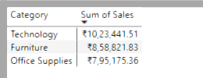

Problem 3: Analysis of the most loss-making product in 2014?

Output:

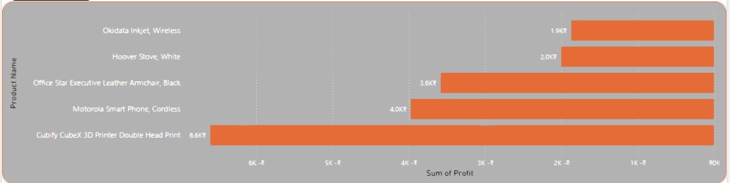

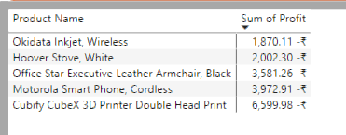

Problem 4: Analysis of the most profitable countries in 2012?

Output:

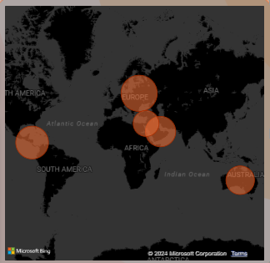

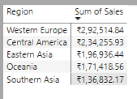

\*\*\*\*\*\*\*\*\*\*\*\*\*\*\*\*\*\*\*\*\*\*\*\*\*\*\*\*\*\*\*\*\*\*The End\*\*\*\*\*\*\*\*\*\*\*\*\*By Shubhendra Kumar